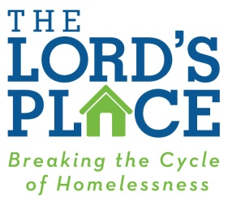

MISSION STATEMENT

The Lord’s Place is dedicated to breaking the cycle of homelessness by providing innovative, compassionate and effective services to men, women and children in our community.

